**AIM:**

**DATE: 04-May-2021**

**Roll no.:18BCE186**

**Name: Prem Desai**

**Course: LAMP TECHNOLOGY**

**2CSDE69**

**Practical No.: 09**

**(A) Using regular expressions check for the validity of entered email-id. The @ symbol should not appear more than once. The dot (.) can appear at the most once before @ and at the most twice or at least once after @ symbol. The substring before @ should not begin with a digit or underscore or dot or @ or any other special character. (Use explode and ereg function.)**

**(B) Using regular expressions validate mobile number and password**

**Methodology followed:**

**9. A**

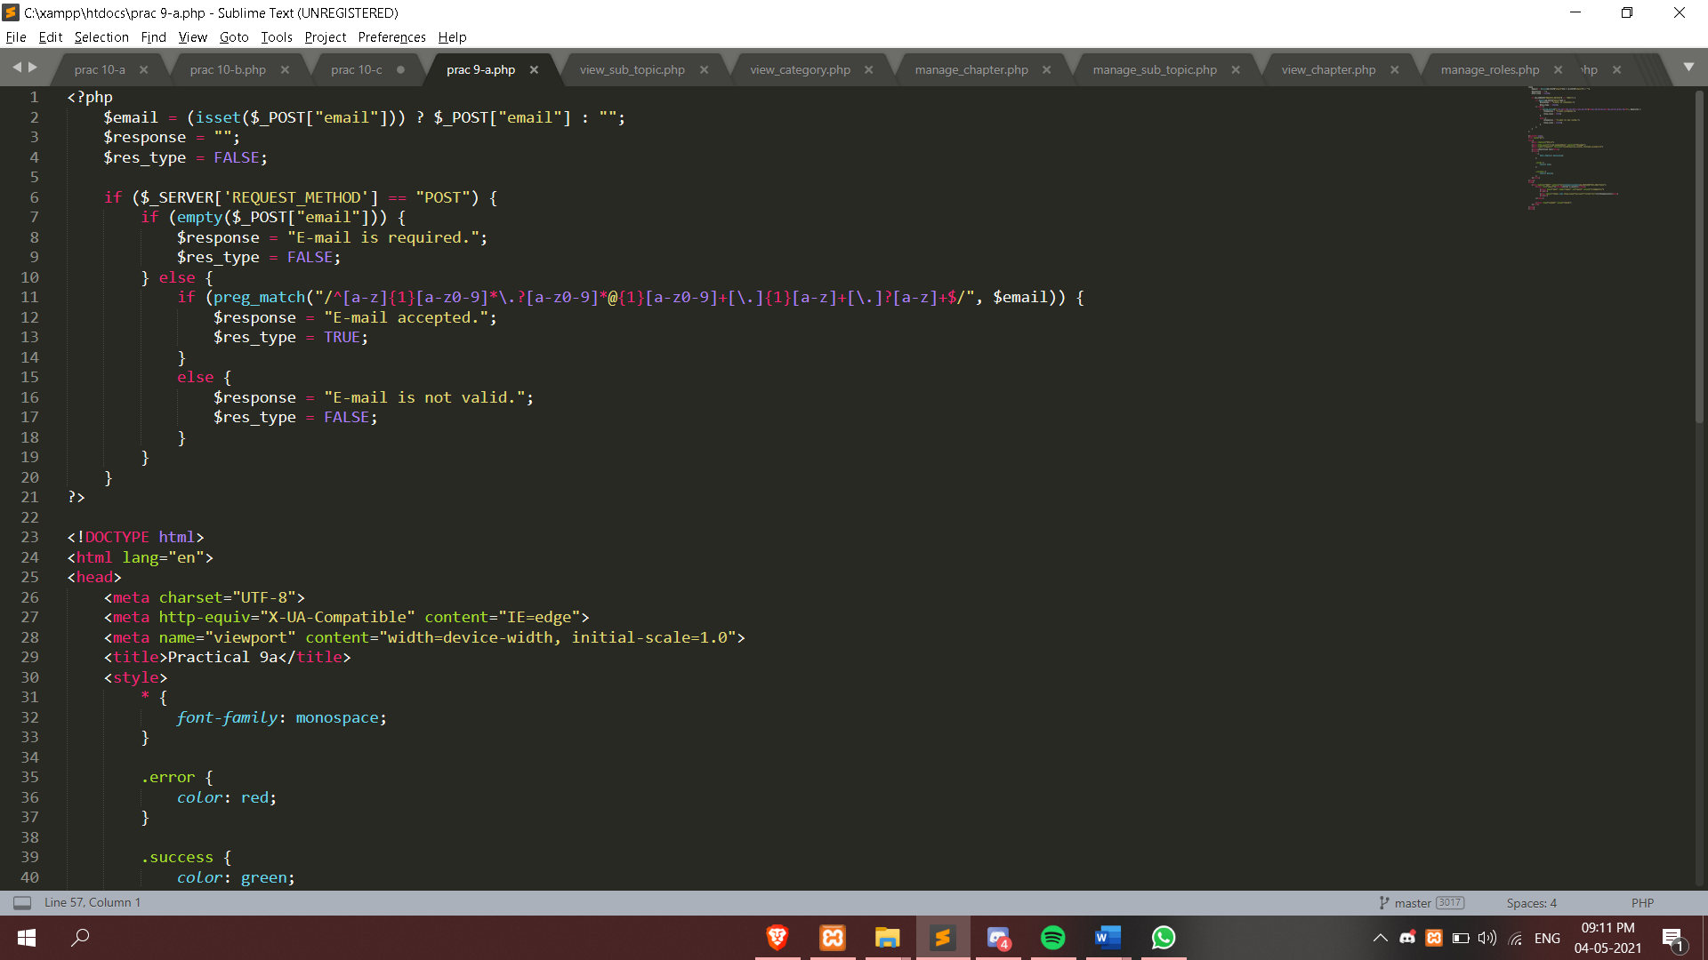

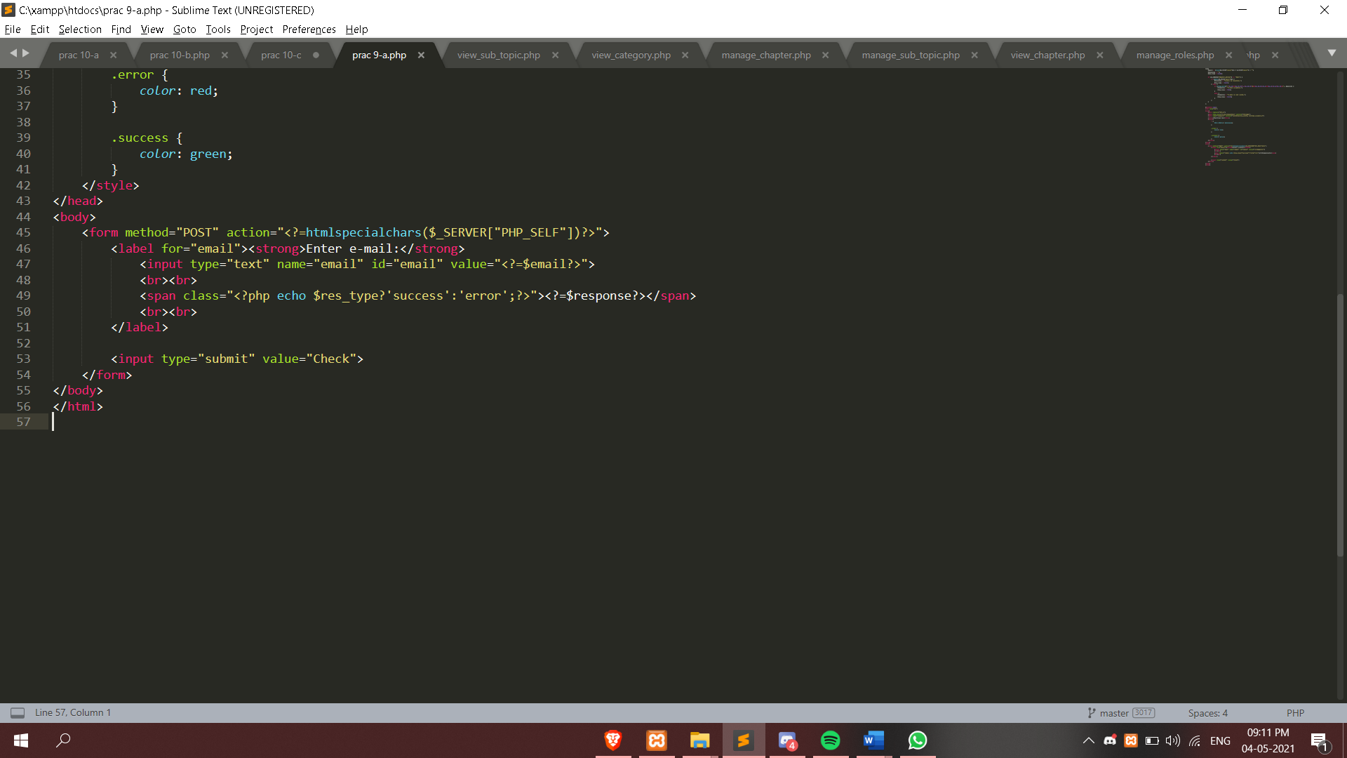

**9. B**

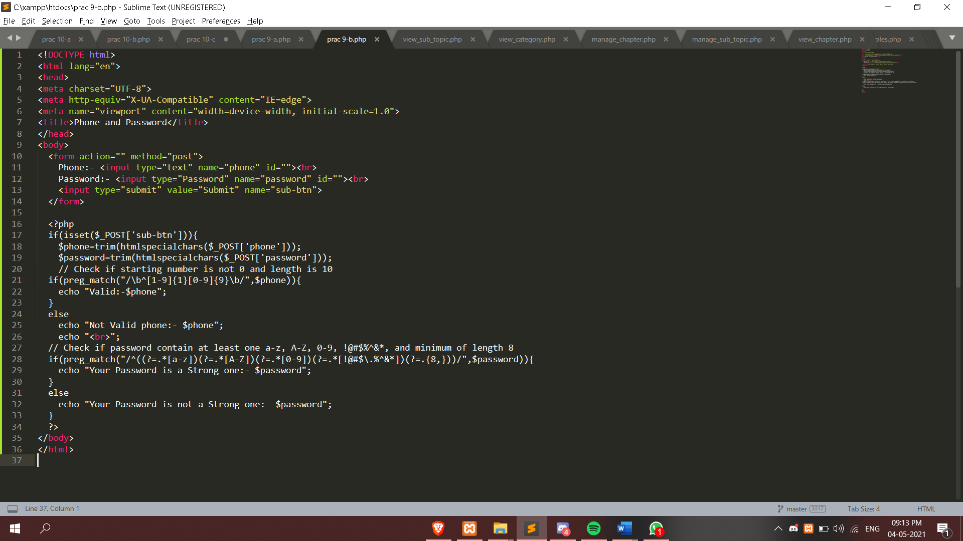

**Output:**

**9.A.**

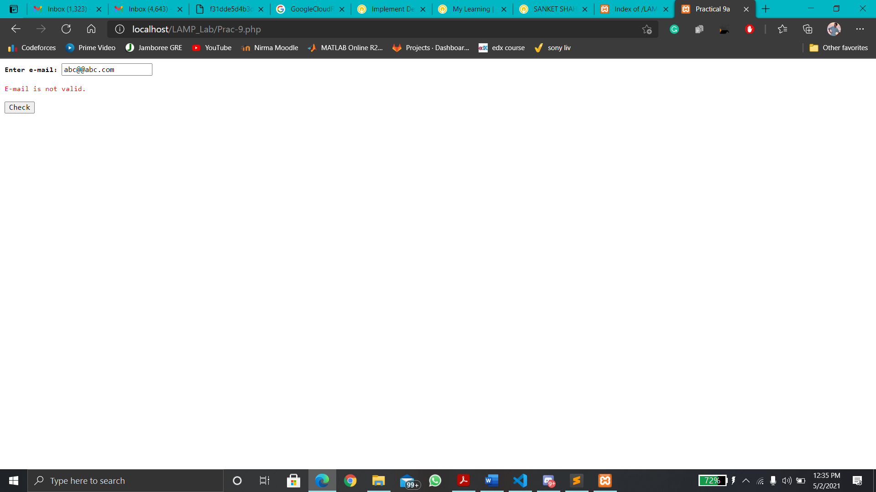

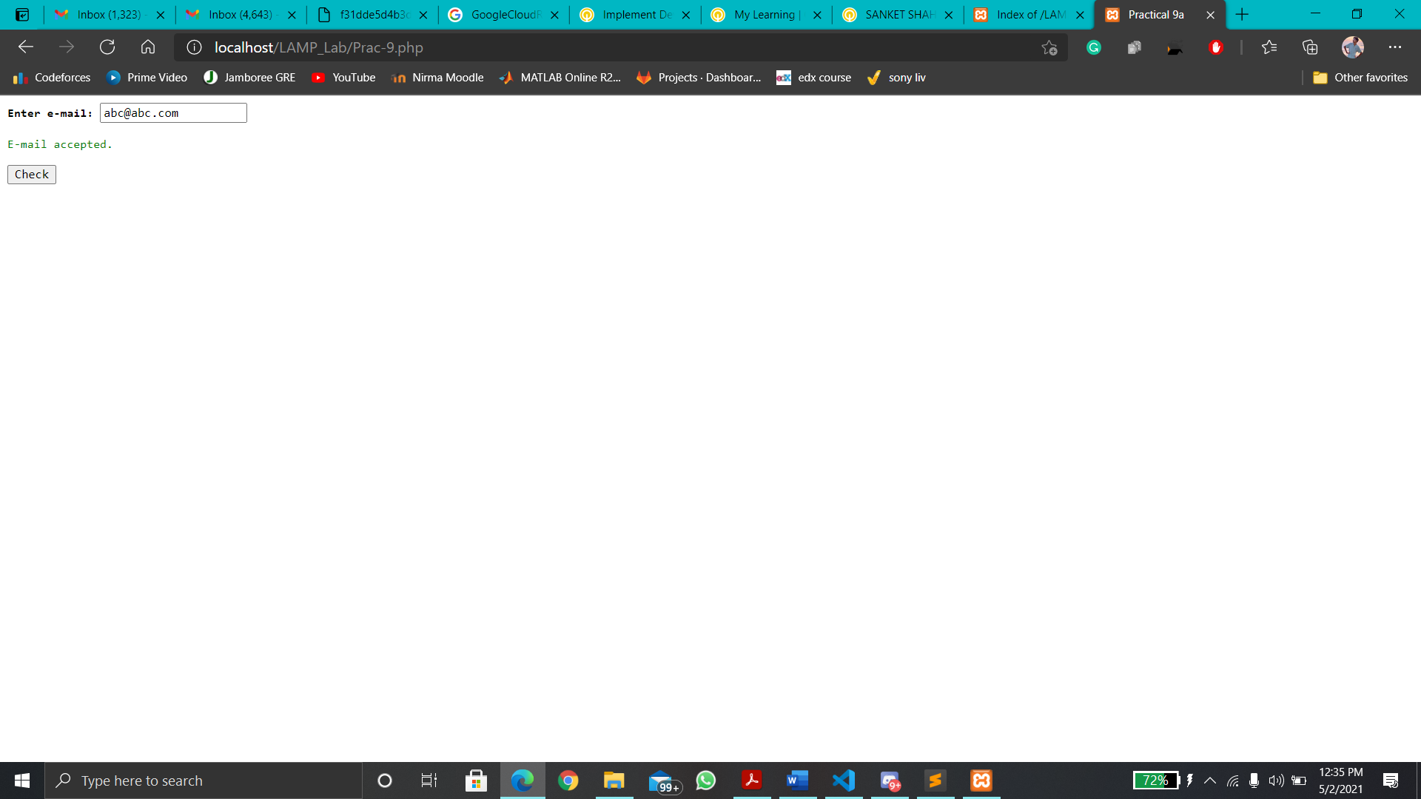

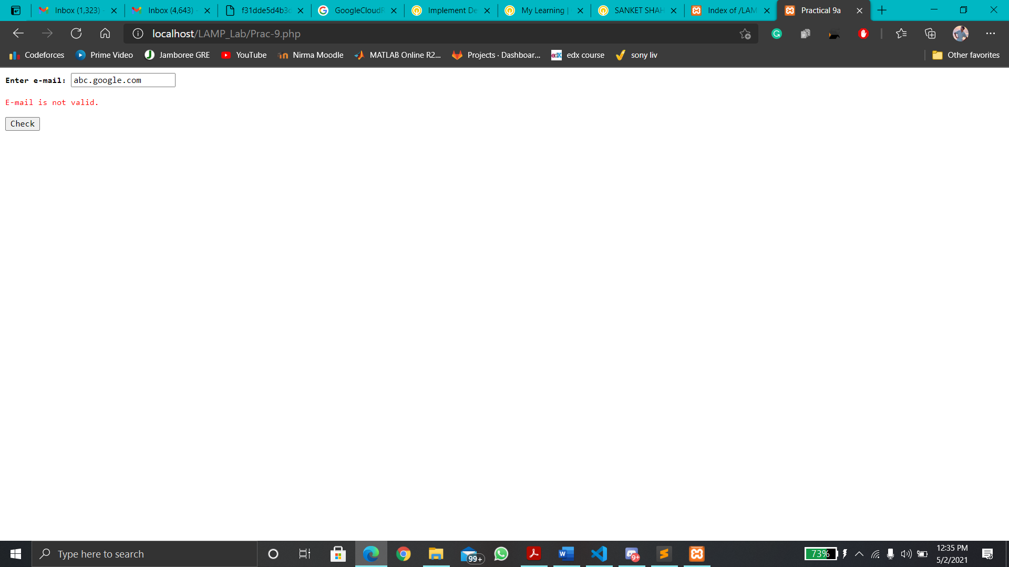

**9. B**

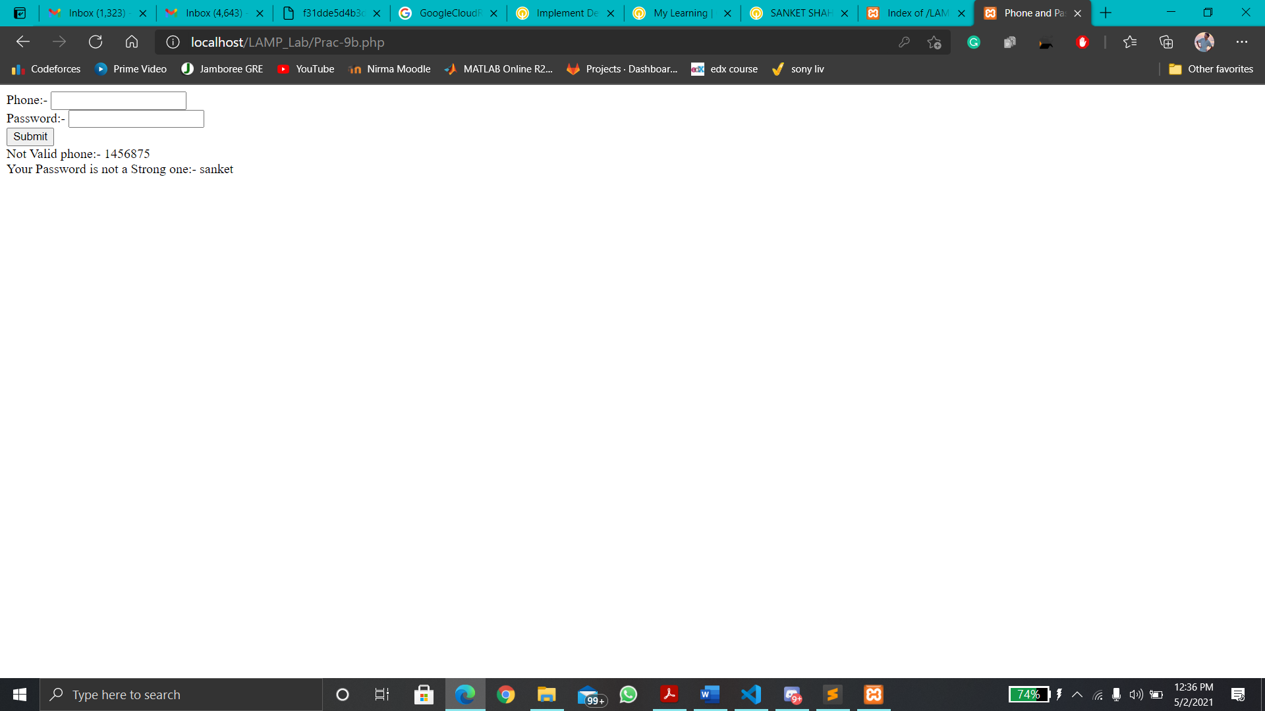

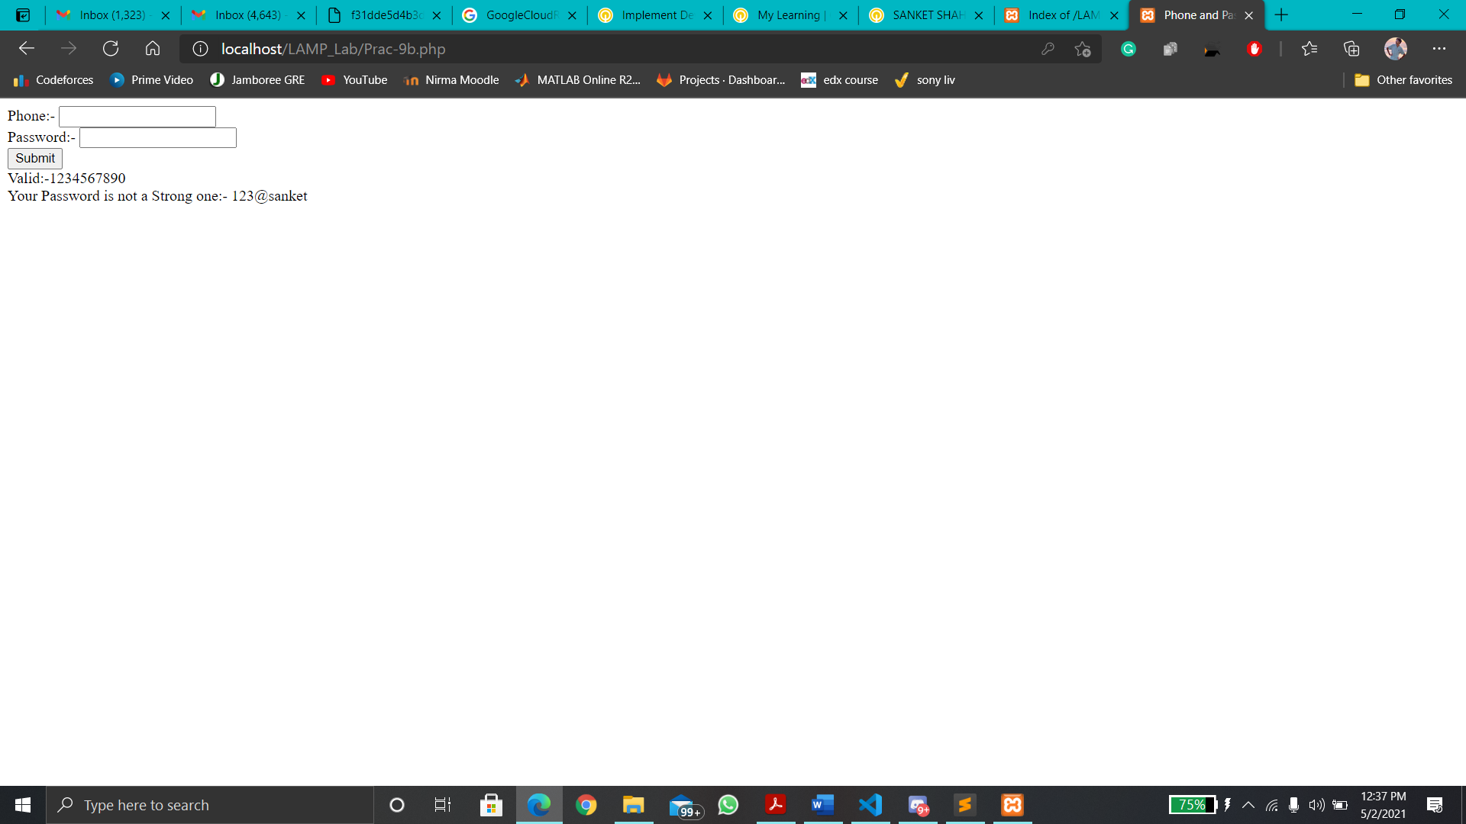

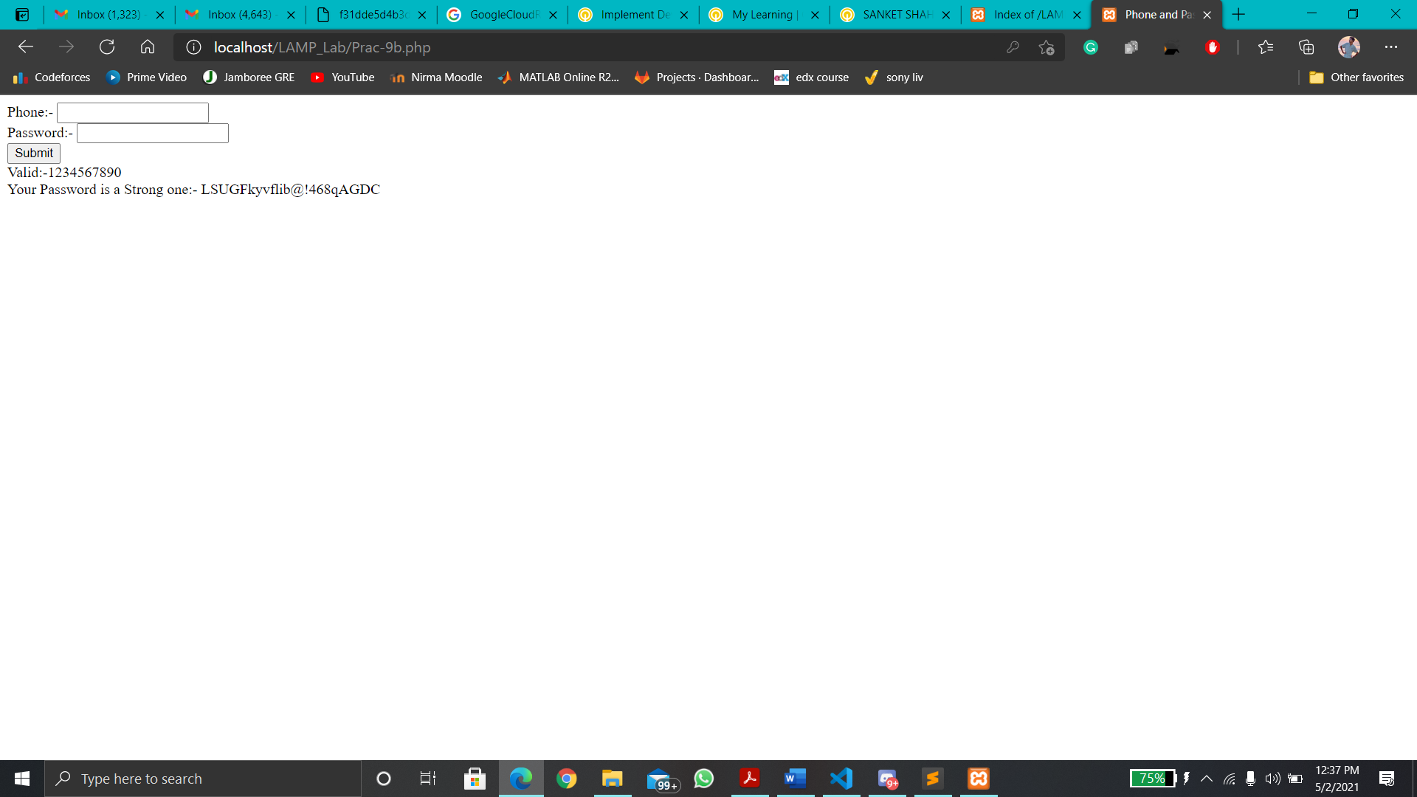

**Conclusion:**

**In this practical, we learnt about regex and how to use it. We validated email id, phone number and password using it.**